IEEE ComSoc gravitas events details

(Have a look at our social media for more info)

2017

**EVENT NAME:TECH-OWRITE**

**DESCRIPTION:**

C. S. Lewis once said, "You can make anything by writing". We at IEEE ComSoc understand the value of words. So, as our first event in GraVITas we introduce Tech-o-write.  
  
This event allows you to spin a story around something technical. It doesn't have to come entirely from you, we will give you the base to build on. All you have to do is give your best.

Even the worst thing you can write is better than the best thing you don't write.

Top of Form

Bottom of Form

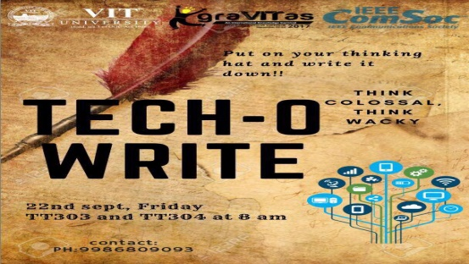 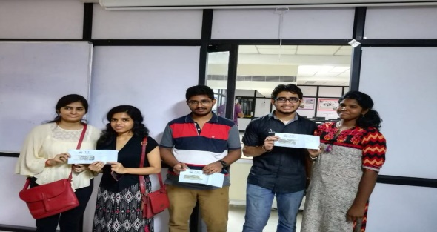

Winners

1st prizeGrace Rodrigues ( 17BEC0252 )   
Arushi Misra ( 17BEC0224 )

2nd prize  
Jeril K Bestin ( 14BEC0728 )  
Febin Shaji ( 15BEC0660 )

3rd prize  
Karan K ( 15BEC0029 )  
Iswariya S ( 15BEC0897 )

Student Coordinator:Hanisha and Vikranth Reddy

2018(Gravitas’18)

1)

**EVENT NAME:VIRTUAL MOUSE**

**DESCRIPTION:**

Ever wondered how the PS4 move , Nintendo Wii or the xbox Kinect worked?  
How easily today so many tasks can be accomplished with just hand gestures?  
So come and learn the fundamentals of gesture control and get your mind blown away by Vicara who'll be teaching these skills and also demonstrate their brilliant work : Kai

Student coordinators-Rajdeep and Vignesh

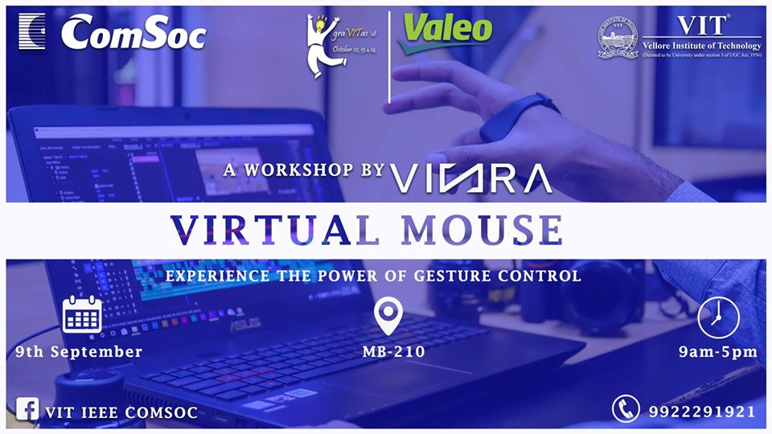

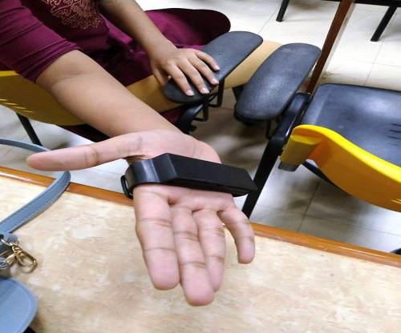 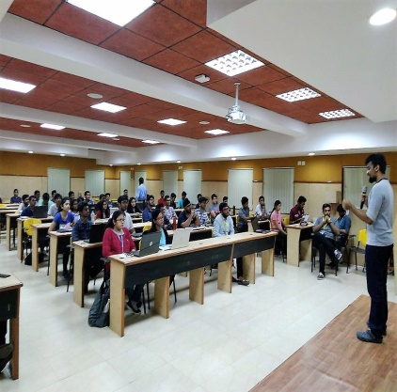 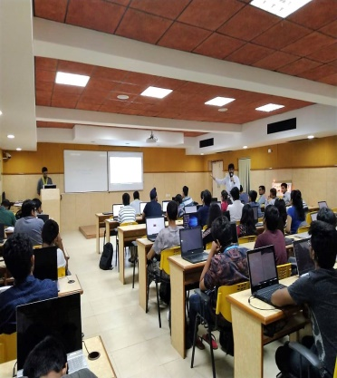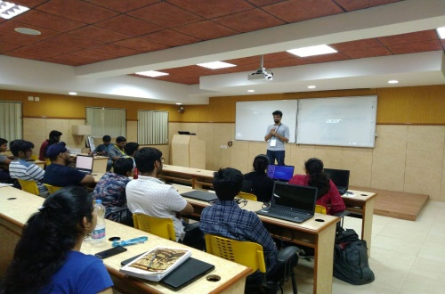 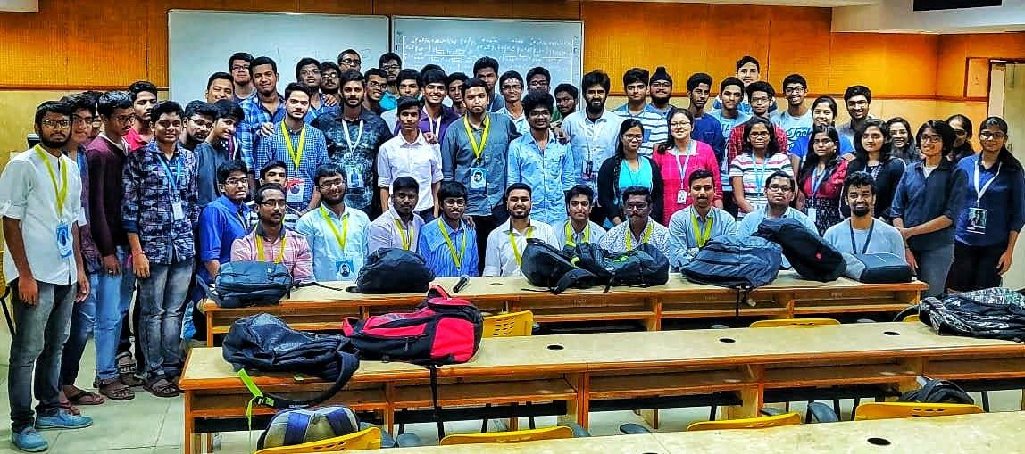

“Success is the result of hard work, perfection & persistence”

After a successful year, we at IEEE Communications Society are back to what we do best. The Virtual Mouse Workshop, which happened as part of Gravitas ’18, was a phenomenal success.

The workshop witnessed participation from 60 enthusiastic students, who were buzzing with the keenness to learn the nuances of image processing & CNNs!

The workshop started with an introductory session about rudimentary image processing & moved on to the technicalities of image analysis. The participants coded in python to capture images from their webcams and perform analysis on them using various image processing algorithms. All the important topics ranging from image segmentation to all the filtering mechanisms were covered.

The most sought-after part of the workshop was, without a doubt, the interactive session that was conducted by Vicara. Vicara is one of the top startups emerging out of the VIT Technology Incubator, that has grabbed the attention of many tech enthusiasts & entrepreneurs alike, for their innovation & cutting edge cost-effective tool which uses gesture controls.

Further, the session moved on to the more challenging topics such as convolution neural networks, machine learning, & coding on python. Other topics like the Haar Transforms & Gradient descent were also covered.

After this resounding success, we at IEEE CoS are energized & rejuvenated to make our next two ventures – ML Workshop & Electronics Premier League a grand triumph.

2)

**EVENT NAME:Electronics Premer League**

**DESCRIPTION:**

Is your performance as dynamic as Gayle? Or do you like to end it in style like Dhoni? Oh wait!!...you prefer to be consistent like Virat? Then what are you waiting for ? Come and unleash the technical player in you in the annual "Electronics Premier League" this GraVITas'18 and become the champion of the champions.  
'Electronics Premier League' --IEEE ComSoc

Student coordinators:Adarsh,Swapnil

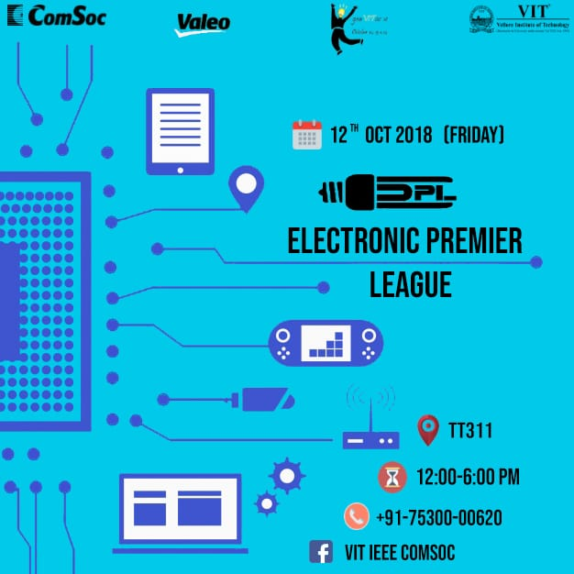

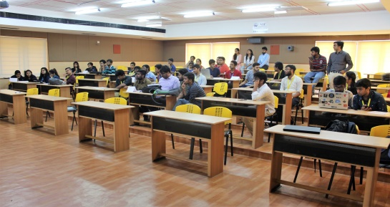 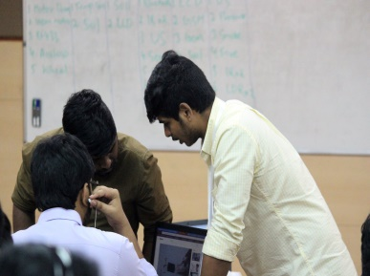 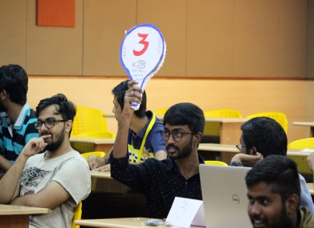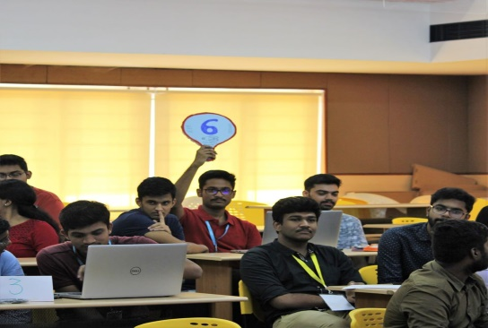 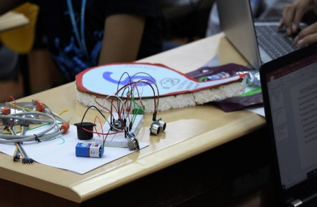 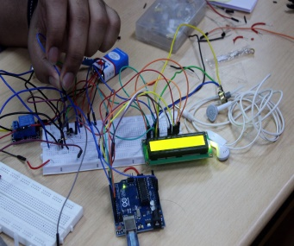 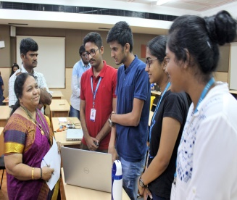 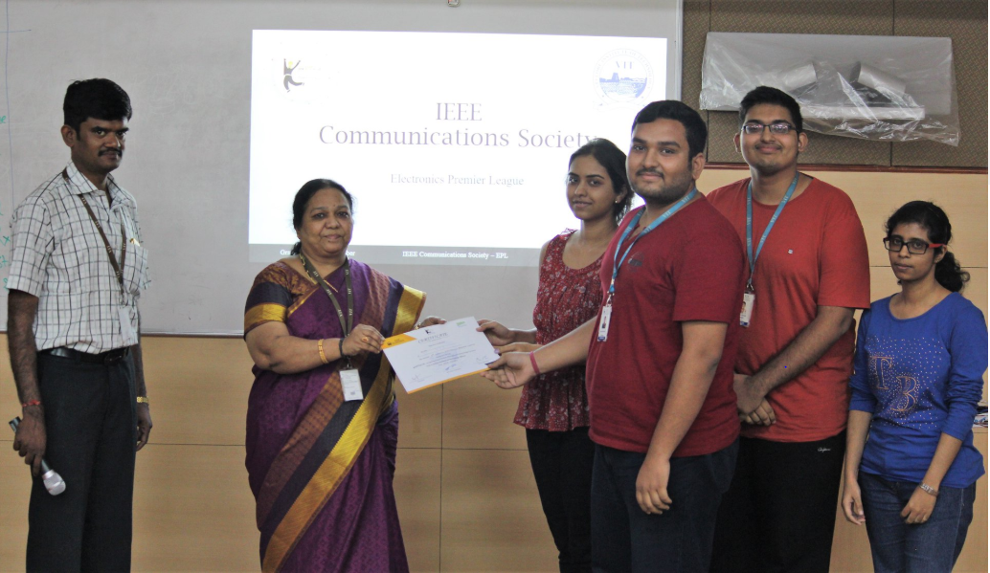 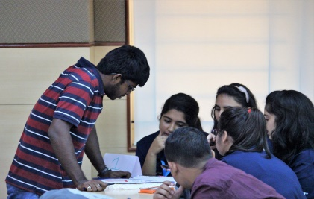

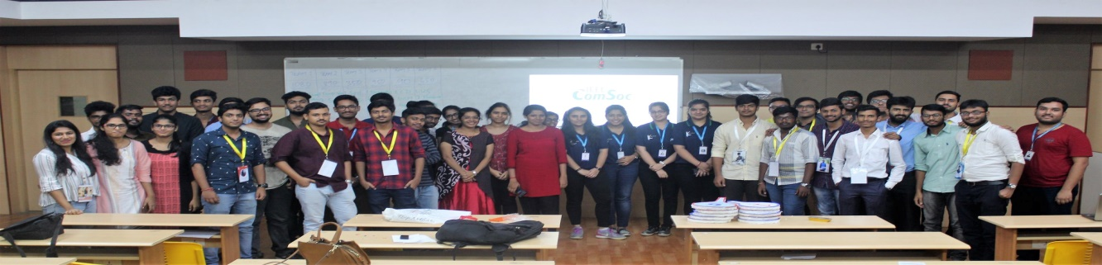

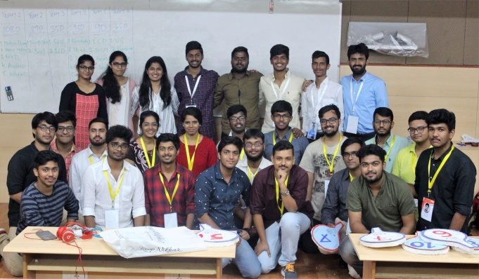 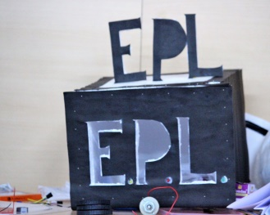

The last event in Gravitas ’18 by IEEE Communications Society chapter was “The Electronics Premier League.” The event required the participants to bid for components that they wanted with virtual currency that was allotted to them. With the components that they purchased, they built projects and pitched the final ideas to a team of judges, led by The HoD of SENSE School & The Faculty Coordinator of IEEE CoS, Prof. Thanikaiselvan Sir & Prof. Jabeena Ma’am.

The event was a grand success, which witnessed participation from over 40 people. The judges appreciated the quality of the projects that came out of the event, & that too in such a short span of time. The judges urged the participants to improve their skills in building projects.

As Gravitas’18 comes to an end, we want to sincerely thank all the participants who turned out for events, and we hope that you learned something from these sessions. We really do hope that our paths cross again. A big thanks to the Management of VIT Vellore & The Gravitas Organizing committee for these wonderful opportunities to make memories and to guide people towards better technical knowledge!

Thank You All & We promise to be back!

3)

**EVENT NAME:Machne Learnng Based self Robotic Arm**

**DESCRIPTION:**

**Student coordinator:Sai Charan**

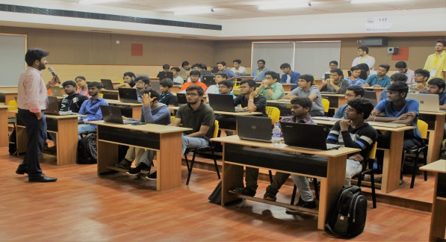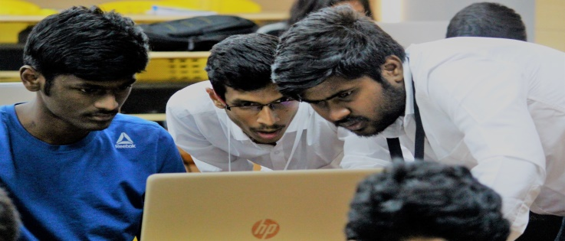

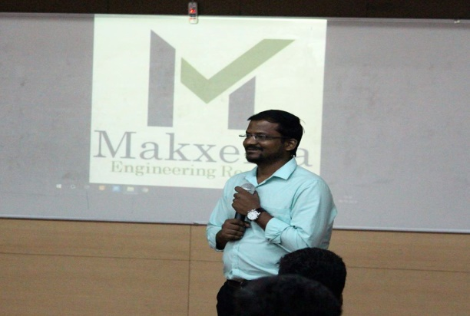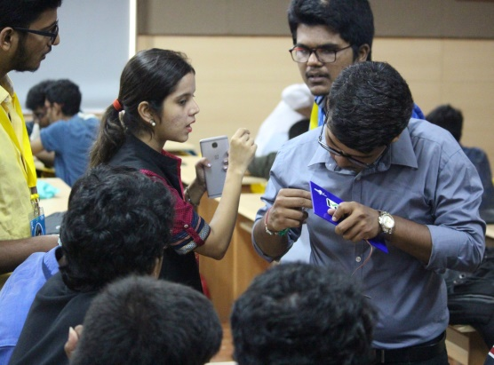

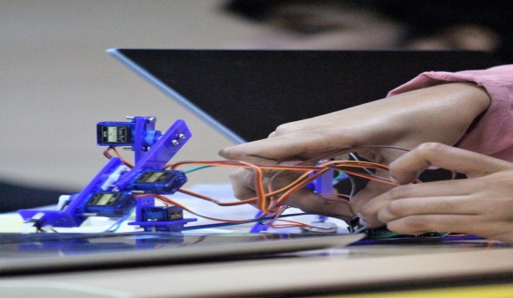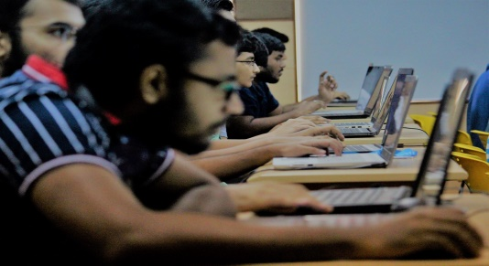

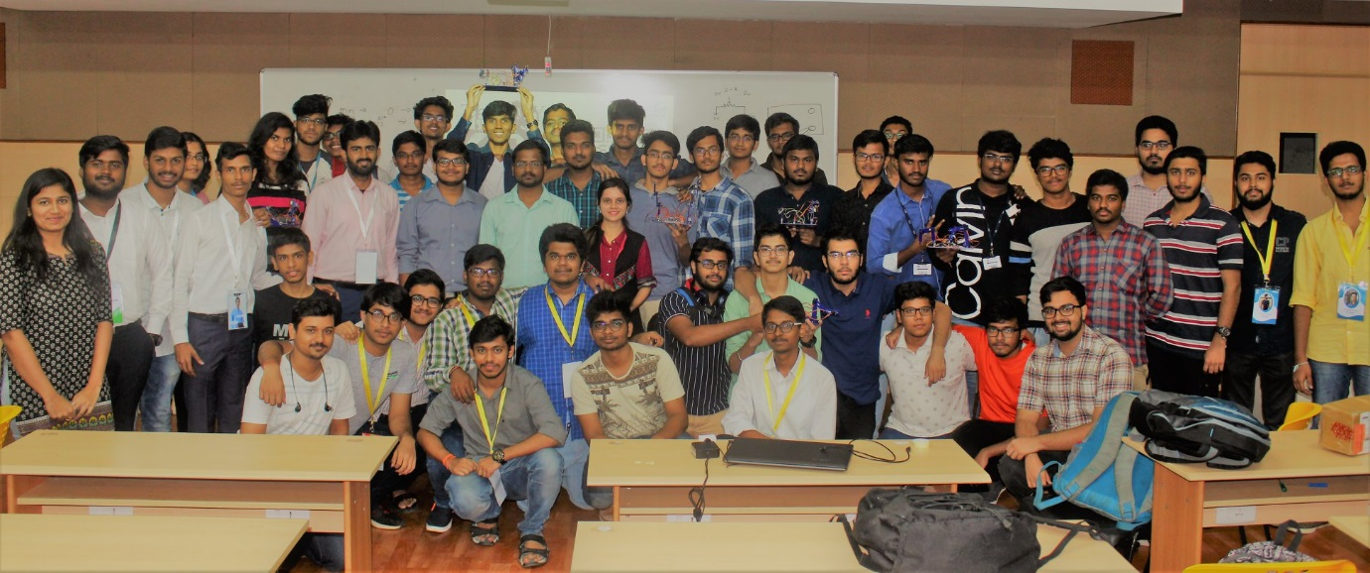

“The secret to continued success is as simple as knowing that your past successes could be done so much better now”

Continuing our success streak, IEEE Communications Society has come up with another triumphant workshop – Machine Learning Workshop with a Self-Learning Robotic Arm. In association with Makxenia, the workshop was conducted in utmost fashion, covering all the theoretical algorithms & important Python coding exercises.

The workshop was kick started with an introduction to Machine Learning and all the different avenues where it’s applied. Further, the basic ideas of data science & ML algorithms were discussed. Later, the enthusiastic participants were exposed to the nuances of Python coding of different important algorithms such as kNN, Classification & Clustering.

The evening session was handled by the experienced professionals from Makxenia company. The participants assembled the robotic arm from scratch and learned a lot about the module while they were at it. An Arduino Nano was integrated with the module to enforce machine learning concepts into the mechanical arm to enable self-learning. The lucid explanation of all the concepts ensured that the participants were able to comprehend the flow.

The success of the Machine Learning Workshop has invigorated in us the motive to make our next venture – Electronics Premiere League – a grand success!

2019(Gravits’19)

1)

**EVENT NAME:Matlab Based Machne Learnng**

**DESCRIPTION:**

It is said...Computers are able to see, hear and learn. Curious to know how?  
Then join us this 7th october to figure out and explore the concept of machine learning using matlab.

Student Coordinators:BharatGupta,Tushar Deora

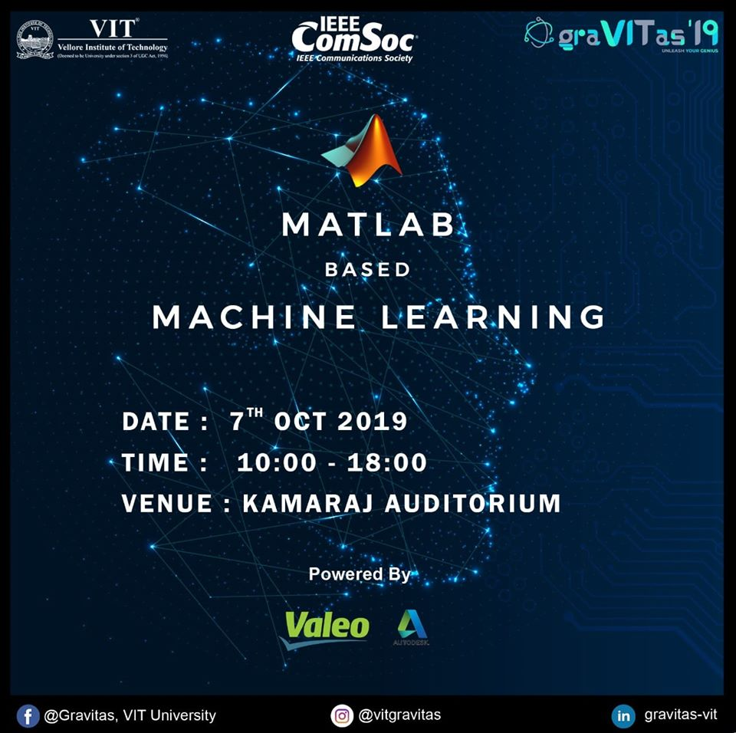

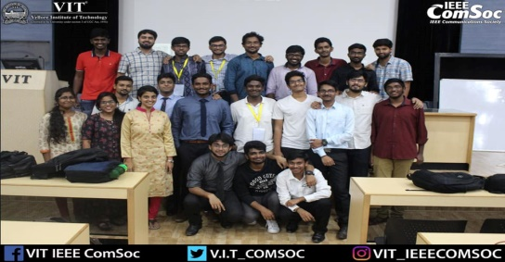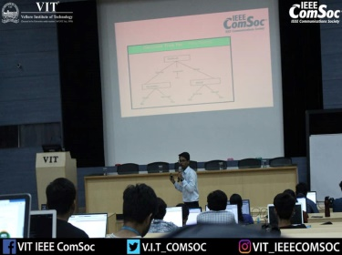 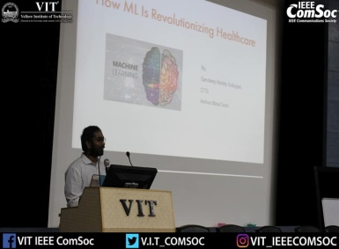

2)

**EVENT NAME:Elecronic Premier League**

**DESCRIPTION:**

* 1. **EPL** is a competitive event based on electronics inspired from the idea of IPL.
* 2. **Team formation-** The contestants would have to participate in teams of 3 or 4 .We commence the event by displaying the components bracket from our inventory (limited components would be provided).
* 3 .**Plan and strategy** -There would be an auction round where teams have to buy the components they require with (limited) virtual money allotted ,brief explanation of components will be given while they are displayed
* 4. **Bidding-** The auction is conducted and the components are distributed among the teams accordingly.
* 5. **Start** -Once the bidding is done, the teams start building their projects.
* 6. **Rebidding** -After about half time, the teams would be given an option to sell their unnecessary components back to us at half the cost price and there would be another round of auction (with components with depreciated prices).
* 7. **Resuming** -The teams then go back to building their projects.
* 8. **Prize Distribution-** The teams will be judged on the basis of their project innovativity and creativity .Prize distribution ceremony to take place.

Student coordinators: Anil and Mahidhar

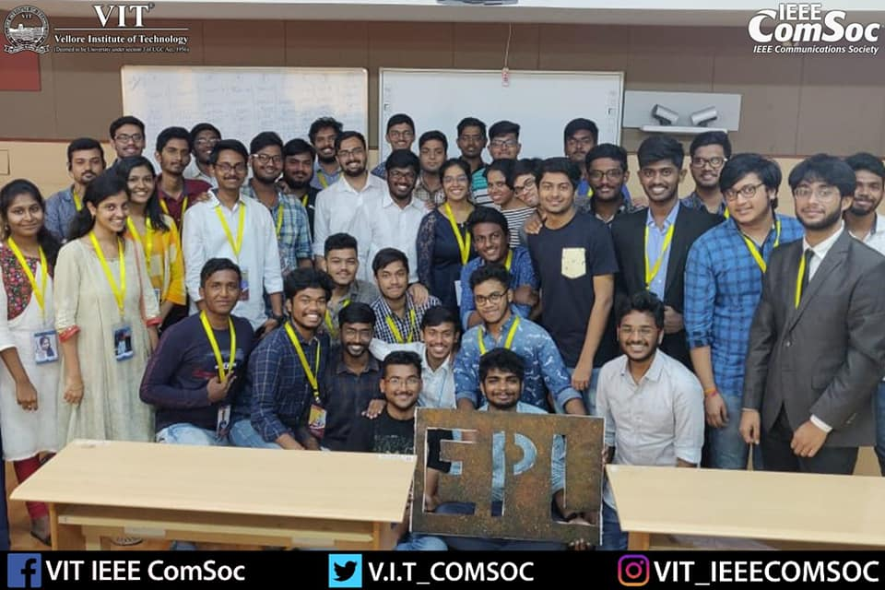 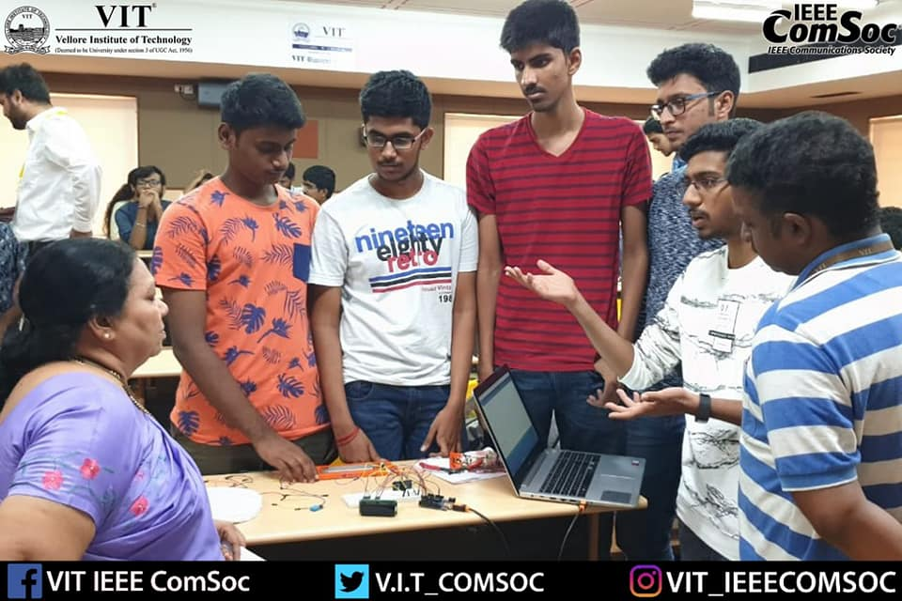

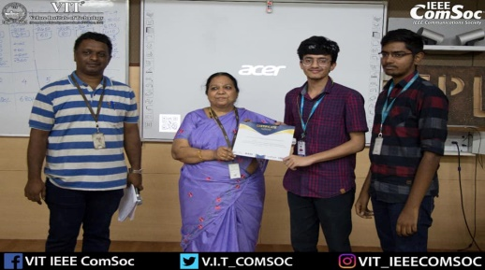 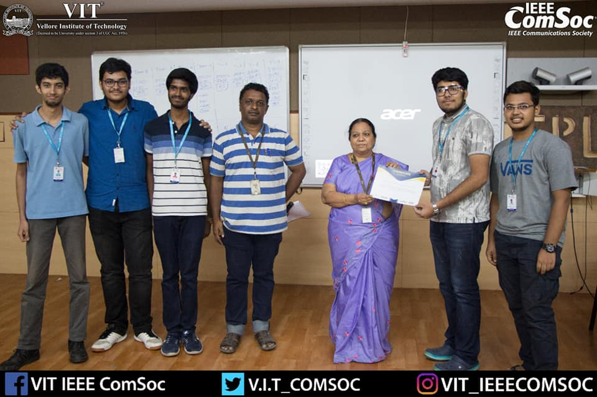

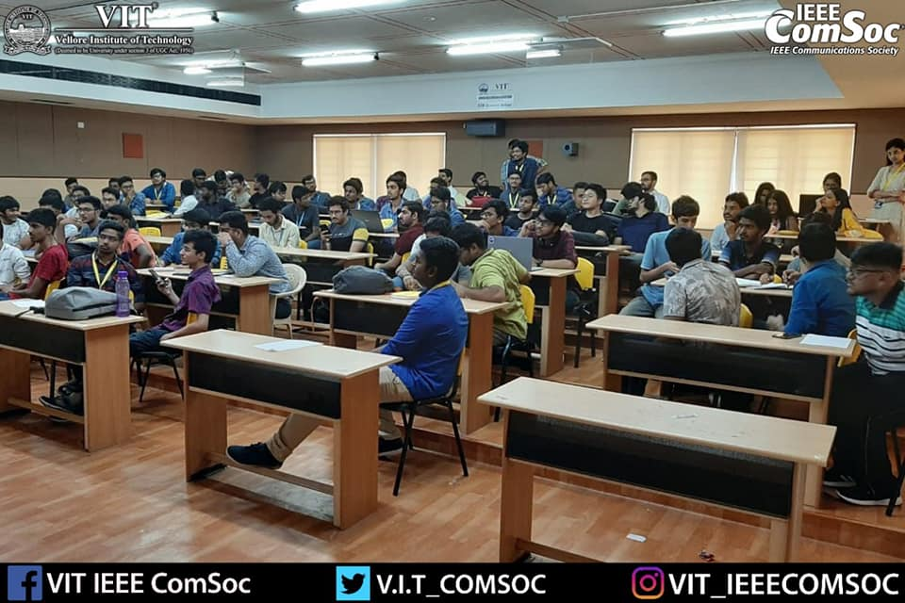 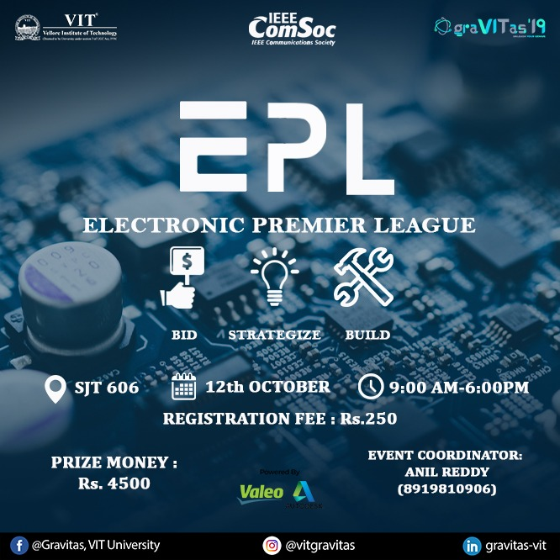

WINNERS

1st prize

Name:Arpit Sharma

Reg no:19BDS0027

2nd prize

1)Name:   Rishikesh Soni

Reg. No.: 19BCE2046

2)Name: Saksham Bhutani

Reg. No.: 19BEC0559

3)Name: Arvind N

Reg. No.: 19BEC0564

4)Name: Hrishikesh Gokhale

Reg. No.: 19BEI0129

5)Name: Anirudh Karnik

Reg. No. 19BEC0353

3rd prize

1) Name:S KAVIN

Reg no:19BEC0677

2) Name:Girish Balaji

Reg no:19BCI0247

3) Name:S.Prasaanth

Reg no:19BEC0016

4) Name:Logesh.S

Reg no:19BCE0839

5)Name:S.Balakrishnan

Reg no:19BEC0745